 | 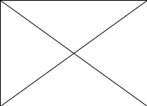

Home IP Address Speed Test Download FAQ Donate Link to Us Contact Us

Select Language​▼

  Frequently Asked Questions
  General
  How to enable Windows Desktop Gadgets in Windows 8 Pro Build 9200?
  Why my Windows desktop gadgets not working or not displaying properly?
  How to fix the subkey with foreign/ASCII character exists under the "Zones" registry key?
  How to fix the XML registration is missing in the system?
  How to delete the Windows Sidebar Setting.ini file and all gadgets file?
  Why my Windows desktop gadgets don't start up automatically?
  How to close Windows desktop gadget?
  How do I uninstall a Windows desktop gadget?
  How to disable or turn off Windows desktop gadgets on Windows 7?
  How to turn on Windows desktop gadgets on Windows 7?
  How to change a Windows desktop gadget's options?
  How to resize a Windows desktop gadget?
  How to always keep Windows desktop gadgets on top of your windows?
  How to bring Windows desktop gadgets to the front by using a keyboard shortcut?
  How to tab through Windows desktop gadgets by using a keyboard shortcut?
  How to hide Windows desktop gadgets on the desktop?
  How to show gadgets on the desktop?
  How many Windows desktop gadgets i can install?
  Network Meter
  How to stop something is downloading in the background without my permission?
  How to disable startup programs?
  GPU Meter
  Why my GPU Meter doesn’t work?
  Drives Meter
  How to fix WMIPRVSE.exe using 100% CPU Usage or cannot collect the data?
  How to fix the disk performance monitoring in the registry was set to disabled?
  PC Meter
  What is PC Meter?
  How to running (install) the PC Meter?
  How to uninstall the PC Meter?
  How to make PC Meter run on Windows startup?
  Other
  How to uninstall the IncrediBar Toolbar?
  How to uninstall the Babylon Toolbar on IE or BabylonObjectInstaller or Browser Manager?
  How to change IncrediBar or Babylon home page?
  How to change IncrediBar or Babylon search provider?
  How to setting to open a new tab page when a new tab is clicked?
  General
  How to enable Windows Desktop Gadgets in Windows 8 Pro Build 9200?
  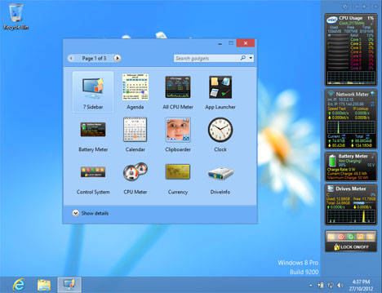
  To enable Windows 8 Gadgets you have to run 3rd party software called 8GadgetPack.
  Here is the Download link: 8GadgetPack
  Here is the website link: http://8gadgetpack.bplaced.net/
  Why my Windows desktop gadgets not working or not displaying properly?
  There are few reasons caused:
  1. A subkey with foreign/ASCII character exists under the "Zones" registry key. How to fix?
  2. XML registration is missing in the system. How to fix?
  3. Something went wrong with Windows Sidebar Setting.ini file and gadgets file. How to delete?
  How to fix the subkey with foreign/ASCII character exists under the "Zones" registry key?
  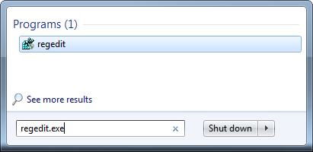
  Click Start or press Windows key --> Type Regedit.exe and press Enter.
  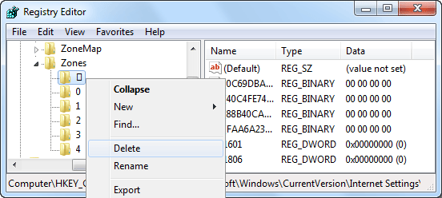
  Navigate to the following branch: HKEY_CURRENT_USER\Software\Microsoft\Windows\CurrentVersion\Internet Settings\Zones
  Under the Zones key right click the ASCII character --> Click Delete --> Click Yes --> Restart your computer.
  How to fix the XML registration is missing in the system?
  Click Start or press Windows key --> Click Start --> Click All Programs --> Click Accessories --> Right-click Command Prompt --> Click Run as administrator.
  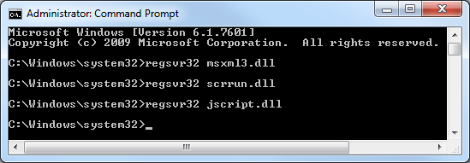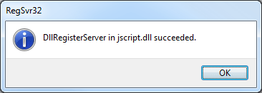
  In the Command Prompt window type regsvr32 msxml3.dll --> Press ENTER --> Click OK --> Type regsvr32 scrrun.dll --> Press ENTER --> Click OK --> Type regsvr32 jscript.dll --> Press ENTER --> Click OK --> Restart your computer.
  How to delete the Windows Sidebar Setting.ini file and all gadgets file?
  The following step will delete all your gadgets. Click Start or press Windows key --> Type taskmgr.exe --> Press ENTER --> Click tab Processes --> Right click sidebar.exe --> Click End Process.
  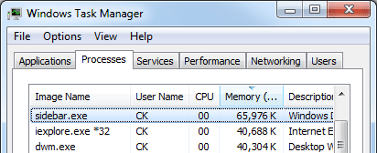
  Click Start or press Windows key --> Type %LOCALAPPDATA%\Microsoft\Windows Sidebar\ --> Press ENTER --> Delete all Gadgets file and Setting.ini.
  Why my Windows desktop gadgets don't start up automatically?
  Maybe you have disable or turn off Windows desktop gadgets.
  To turn on click Start or press Windows key --> Click Control Panel --> Click Programs --> Click Programs and Features --> Click Turn Windows features on or off --> Click the checkbox from Windows Gadget Platform --> click OK --> Restart your computer.
  How to close Windows desktop gadget?
  Right-click the gadget that you want to close, and then click Close gadget.
  How do I uninstall a Windows desktop gadget?
  Close gadget --> Restart your computer --> Right-click the desktop --> Click Gadgets --> Right-click a gadget that you want to uninstall --> Click Uninstall.
  How to disable or turn off Windows desktop gadgets on Windows 7?
  Click start or press Windows key --> Click Control Panel --> Click Programs --> Click Programs and Features --> Click Turn Windows features on or off --> Remove the checkbox from Windows Gadget Platform --> click OK --> Restart your computer.
  How to turn on Windows desktop gadgets on Windows 7?
  Click start or press Windows key --> Click Control Panel --> Click Programs --> Click Programs and Features --> Click Turn Windows features on or off --> Click the checkbox from Windows Gadget Platform --> Click OK --> Restart your computer.
  How to change a Windows desktop gadget's options?
  Right-click the gadget that you want to change, and then click Options.
  (Some gadgets might not have options.)
  How to resize a Windows desktop gadget?
  Right-click the gadget that you want to resize --> Click Options --> Choose size --> Change the percentage you want the gadget to be.
  (Some gadgets can't be resized.)
  How to always keep Windows desktop gadgets on top of your windows?
  Right-click a gadget --> Click Always on top.
  How to bring Windows desktop gadgets to the front by using a keyboard shortcut?
  Press the Windows Logo key + G.
  How to tab through Windows desktop gadgets by using a keyboard shortcut?
  Press the Windows Logo key + G, and then continue pressing G to select the gadgets.
  How to hide Windows desktop gadgets on the desktop?
  Right-click the desktop --> Point to View --> Click Show desktop gadgets to clear the check mark. (Hide your gadgets doesn't close or remove them from the desktop. Still running in background.)
  How to show gadgets on the desktop?
  Right-click the desktop --> Point to View --> Click Show desktop gadgets.
  How many Windows desktop gadgets i can install?
  There is no limit.
  Network Meter
  How to stop something is downloading in the background without my permission?
  First scan the computer using the latest antivirus, Anti-Spyware and Anti-Malware programs.
  Second close all programs (i.e. Internet Explorer, Skype, etc).
  Third you should be concerned with all programs that start automatically then disable the program and restart the computer.
  How to disable startup programs?
  Click Start --> click Run or Search promgrams and files --> then type: MSCONFIG and click OK --> click Startup tab --> uncheck the programs you don't want to start when your computer boots (do not uncheck your antivirus program) --> click OK --> then restart the computer.
  GPU Meter
  Why my GPU Meter doesn’t work?
  Because it request running the PC Meter in background each time you use the GPU Meter Version 2.0.
  Drives Meter
  How to fix WMIPRVSE.exe using 100% CPU Usage or cannot collect the data?
  Click Start --> Click All Programs --> Click Accessories --> Right-click Command Prompt --> Click Run as administrator --> In the Command Prompt window type lodctr /r --> Press ENTER.
  How to fix the disk performance monitoring in the registry was set to disabled?
  Click Start or press Windows key --> Type Regedit.exe and press Enter --> Navigate to the following branch: HKEY_LOCAL_MACHINE\SYSTEM\CurrentControlSet\Services\Perfdisk\Performance
  If you find a value named Disable Performance Counters listed there and the value is 1 (mean disable) just change it to 0 (mean enable) and then restart the computer.
  PC Meter
  What is PC Meter?
  PC Meter is use for detect the graphic card information, CPU temperatures and processor turbo frequency (Overclock).
  How to running (install) the PC Meter?
  1. Download the PC Meter
  2. Extract (Unzip) all files
  3. Right click PCMeter application and choose Run as administrator
  How to uninstall the PC Meter?
  To uninstall just delete all the PC Meter file.
  How to make PC Meter run on Windows startup?
  To make PC Meter run on Windows startup: Open PC Meter --> Click Options --> Select Run On Windows Startup.
  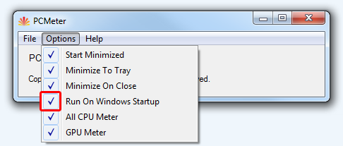
  If PC Meter still can't run on Windows startup you can try use this startup folder method: Click Start or press Windows key --> Click Start --> Click All Programs --> Right click Startup --> Click Open --> Right click on Startup Windows Explorer --> Select New and click Shortcut --> Browse the PCMeterV0.3.exe --> Click Next -- Click Finish to save. The PC Meter will run on the next Windows Start.
  Other
  How to uninstall the IncrediBar Toolbar?
  Click start or press Windows key --> Click Control Panel --> Click Uninstall a program --> Right click IncrediBar in the list --> Click uninstall.
  How to uninstall the Babylon Toolbar on IE or BabylonObjectInstaller or Browser Manager?
  Click start or press Windows key --> Click Control Panel --> Click Uninstall a program --> Right click Babylon in the list --> Click uninstall.
  How to change IncrediBar or Babylon Internet Explorer home page?
  For Internet Explorer 9
  Open Internet Explorer --> Open the web site you want to set as your home page --> Click Tools or press the shortcut key Alt+X --> Click Internet Options --> Click General tab --> Under Home page click Use Current --> Click OK to save your changes.
  For Firefox
  Open Firefox --> Open the web site you want to set as your home page --> Click the web site icon and drag it to the Home button --> Release the click --> Click OK to save your changes.
  For Google Chrome
  Open Google Chrome --> Open the web site you want to set as your home page --> Click the wrench icon or press the shortcut key Alt+F --> Click Settings --> Click Open a specific page or set of pages --> Click Use current pages --> Click OK to save your changes.
  How to change IncrediBar or Babylon search provider?
  For Internet Explorer 9
  Open Internet Explorer --> Click Tools or press the shortcut key Alt+X --> Click Manage Add-ons --> Click Search Providers --> Right click the search provider you would like to set as default --> Click Set as default.
  How to setting to open a new tab page when a new tab is clicked?
  For Internet Explorer 9
  Open Internet Explorer --> Click Tools or press the shortcut key Alt+X --> Click Internet Options --> Click General tab --> under Tabs click Settings --> Click the list under When a new tab is opened, open, --> Choose The new tab page --> Click OK to save your changes.
  Gadgets Gallery
  All CPU Meter
  Network Meter
  GPU Meter
  Drives Meter
  Battery Meter
  Digital Clock
  Amazon Search
  Earthquakes Meter
  Control System
  World Clock
  Fix 64 bit sidebar
  IP Tools
  IP Location
  IP Blacklist Check
  Whois IP
  Whois Domain

Copyrighted © 2007-2013 addgadgets.com All rights reserved. Follow Me On twitter PAD Files Privacy Policy Terms Of Use Site Map

